installation of code-blockS for c++

This page is about how to install Code-Block for C++ and how to create a project on Code-Block.

Assignment # 01 BY Sir Ahmed Raiz

Installation Code Blocks for C++ on:

Follow the below steps to install Code Blocks  for C++ on:

**Step 1:** Open Your Web Browser

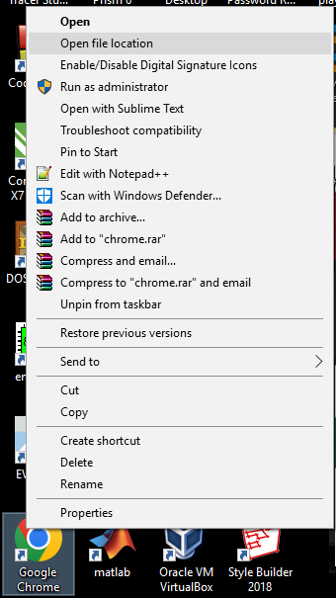



**Assignment No 1**

**Submitted By:**

**Name : Haseeb Ullah**

**ID : F20232661009**

**Section : V21**

**Submitted To:**

**Sir Raiz Ahmed**

**Subject : ICT LAB**

**Due Date : 07/11/2023**

C-II Block C 2 Phase 1 Johar Town, Lahore, Punjab 54770

How to Install Code Blocks for C++ on Windows?

**Step 1:**Open the Chrome.

0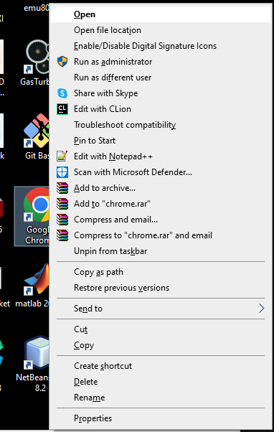

**Step 2:**Go to the Search Panel and Search for “Code Blocks”

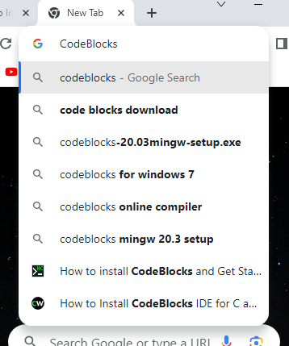

**Step 3:** Click on the First Result shown on the Search Engine or click on this Link:

<https://www.codeblocks.org/>

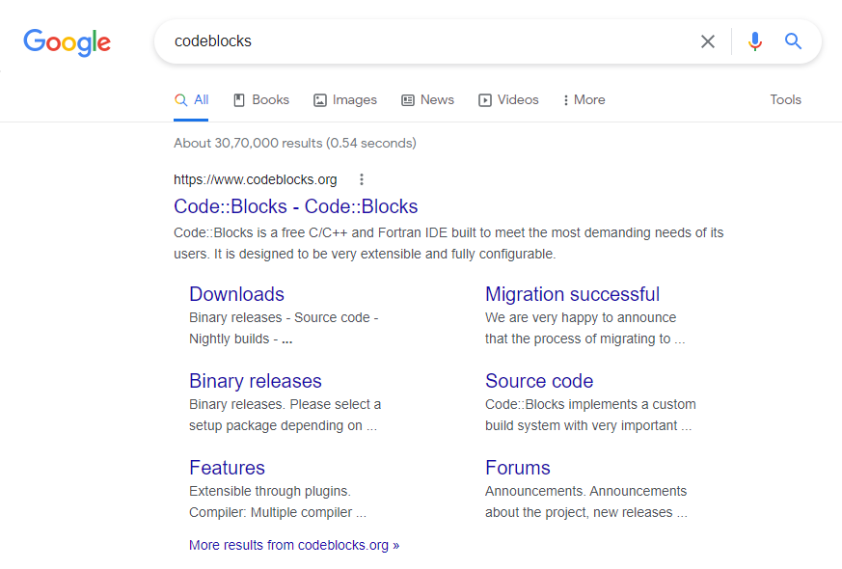

**Step 4:** Click on the “Downloads” Section.

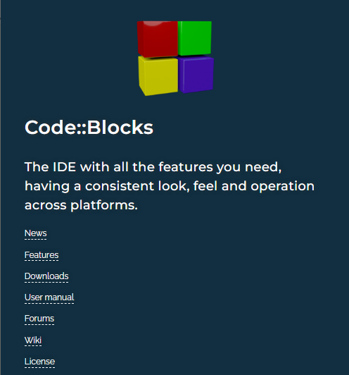

OR

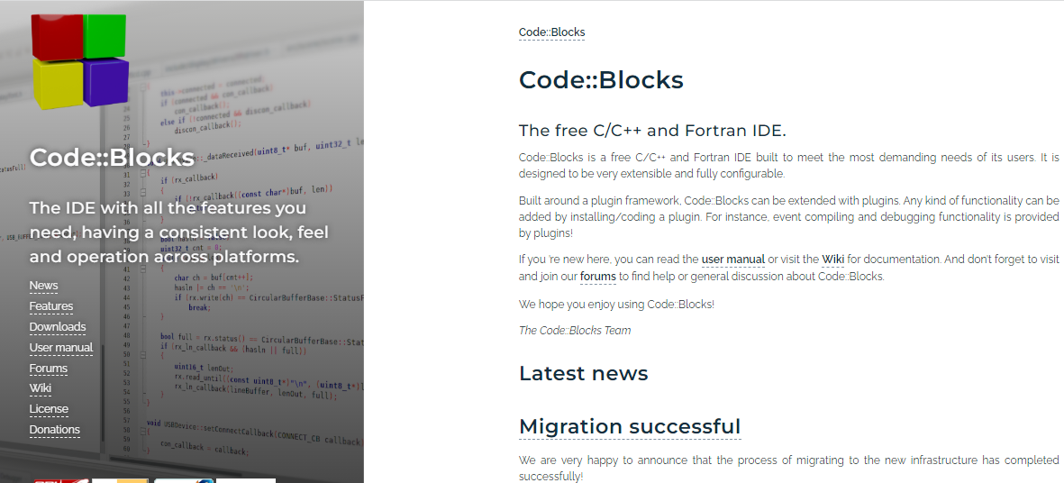

**Step 5:** Click On “Download the binary release”.

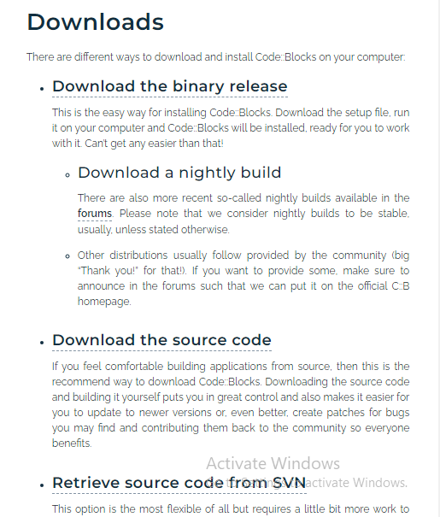

**Step 6**: As per this Date, the Latest Version of Code Blocks is 20.03. Now here you’ll find several download options

1. codeblocks-20.03-setup.exe : It is a standard executable file that is easier to install.
2. codeblocks-20.03-nosetup.zip : It is a zip file which you do not have to install , you can just unzip and run it.

I’ll suggest you download the file with MinGW written on it (“codeblocks-20.03mingw-setup.exe”) as MinGW is a Compiler that is needed to run the Program. If you download the normal setup file then you have to download The compiler separately.

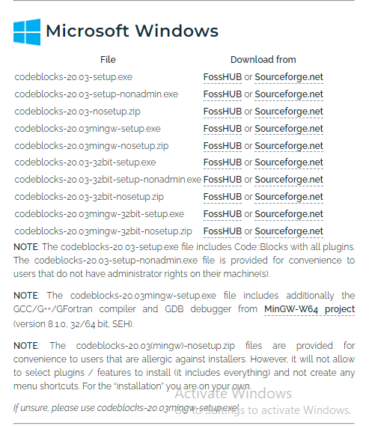

**Step 7:** Click on Sourceforge.net under the Download Section of your desired file.

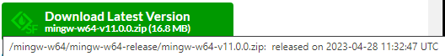

**Step 8:** then Download should begin within some seconds.

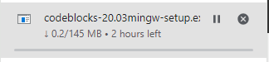

**Step 9**: When the download is completed, Open Your Code Blocks Setup File.

**Step 10:** Click on Next.

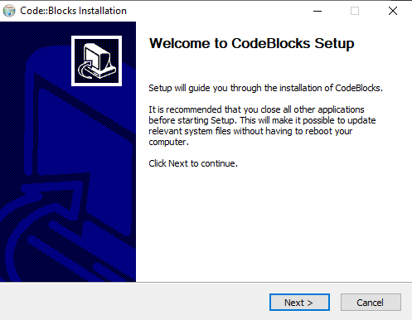

**Step 11:** Click on I agree.

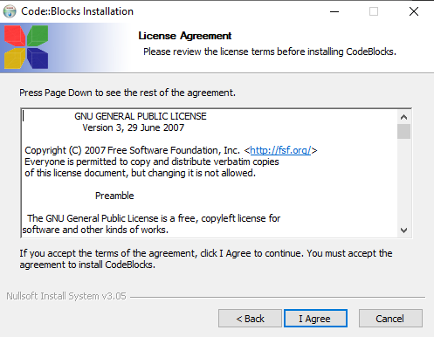

**Step 12:** Click On Next ( you need to have at least 600 MB free storage on your drive for the installation).

**Step 13:** Select your Destination and Click on Install

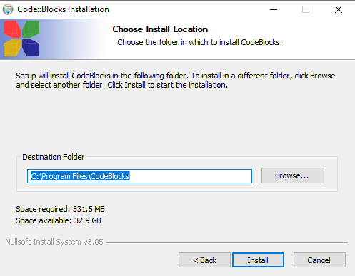

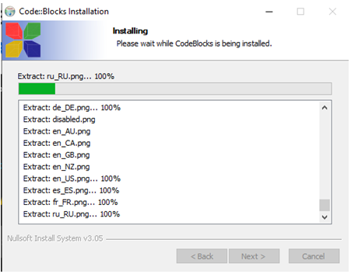

**Step 14**: Once Installation gets completed, click on Next and then Click on Finish.

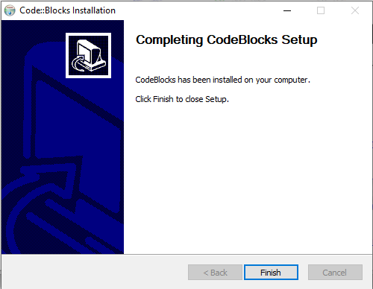

Now You Code Blocks have been installed.

**To Set the Environment Path of GCC compiler.**

**Step 1**: Go to your Code Blocks MinGW installation folder location ( For me it is C:\Program Files\CodeBlocks\MinGW\bin) and copy the address

**Step 2:**  Go to Search Panel and type “**Edit System environment variable**s”

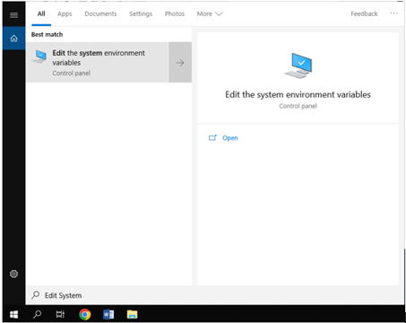

**Step 3**: Click On Environment Variables

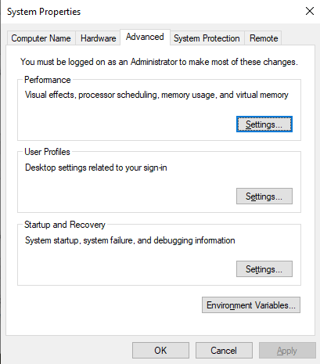

**Step 4**: Under System variables, Click on Path and Select Edit

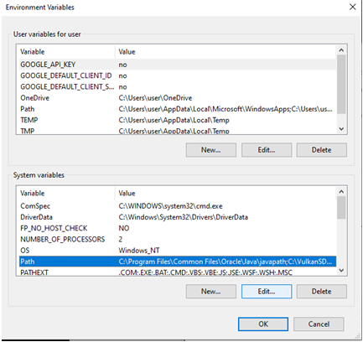

**Step 5:** Click on New and Paste the Address into it and click  on OK

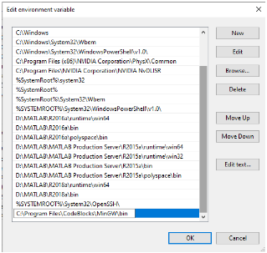

Now Code Blocks will automatically detect GCC Compiler.

**Step 6:** Now simply open it from DESKTOP or LOCATION which is (c:/program file/Code Block).

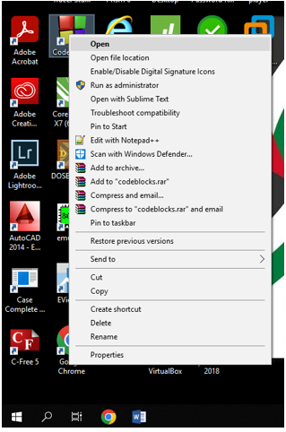

How to create new C/C++ project in CodeBlocks

Code::Blocks:

 is a IDE(Integrated Development Environment) for creating C/C++ projects. It is simple to use and provides very basic but powerful interface. CodeBlocks can be used for creating, editing, compiling, running and debugging C/C++ projects. Here is a beginner guide to use CodeBlocks.

Before preceding you must have CodeBlocks with C/C++ compiler installed in your computer. If you don’t have CodeBlocks installed download and install it before moving to the next step.

**Step 1:**Open CodeBlocks:



**Creating new C/C++ projects**

**Step 2:**Click on File → New → Project.

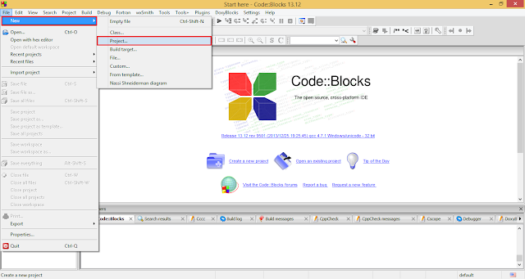

**Step 3**:Select **Console application** from the project category and then click on **Go** button.

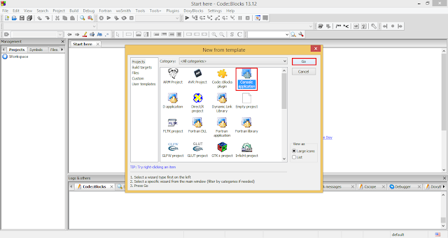

**Step 4**:On the Welcome message dialog box, check the **Skip this page next time** checkbox. And click on **Next** button.

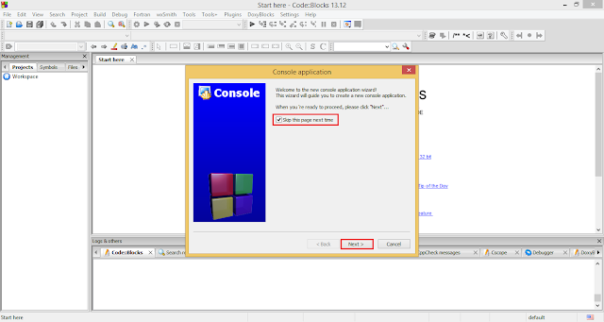

**Step 5**:On next screen the wizard ask you to choose the project type. Choose **C** if you want to create C project else choose **C++** if you want to create C++ project and click on **Next** button.

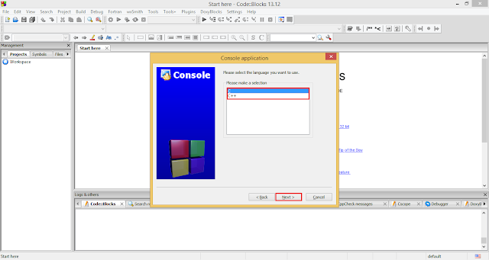

**Step 6**:Next wizard screen enter your **Project title and path where to store your project**. Enter any title of your project suppose Hello World. Choose the file path where you want to store your C files. For choosing file path click on … button. And click on **Next** button.

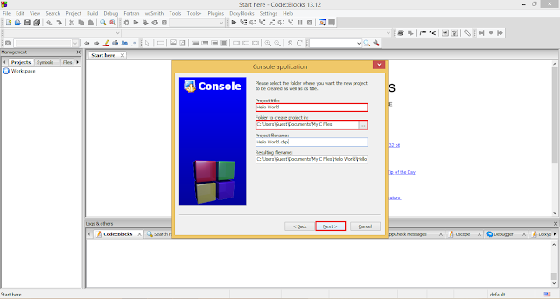

**Step 7**:The next screen asks you to choose C/C++ compiler. If you have installed GNU C/C++ compiler then you need not to perform any action on this screen simply click on **Finish** button. If you don’t have GNU C/C++ compiler download it before preceding to next step.

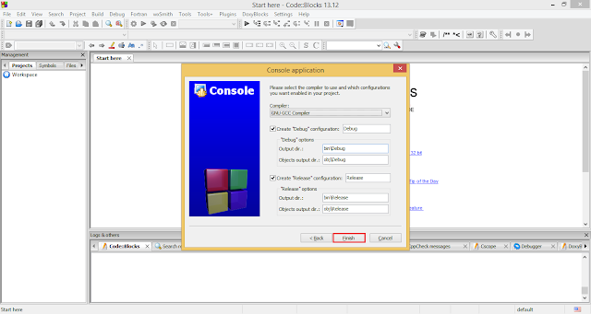

**Step 8**:Congratulations you have created your first C/C++ project in Code::Blocks. But where do I write my first C/C++ program as no editor opens after last step. To open the code editor, navigate to the workspace area and click on **+** symbol present before Sources. That will expand the sources folder. Now double click on **main.cpp** file to open the code editor.

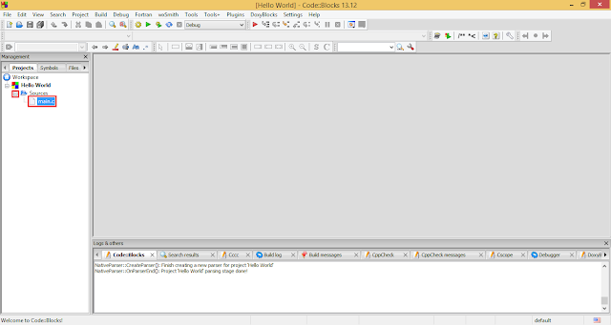

**Step 9**:Finally the code editor opens. Here you can edit you code, for saving your code just press **Ctrl+S**.

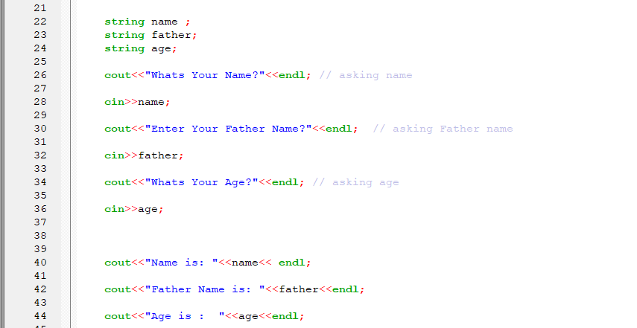

**Running your C/C++ program**

**Step 1**:To run any C/C++ program click on Build → Build and run or simply hit **F9** from your keyboard.

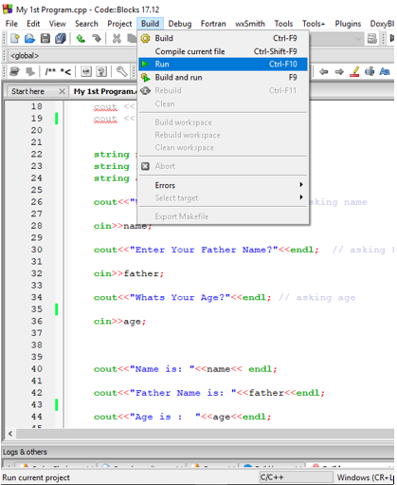

**Step 2**:The output screen.

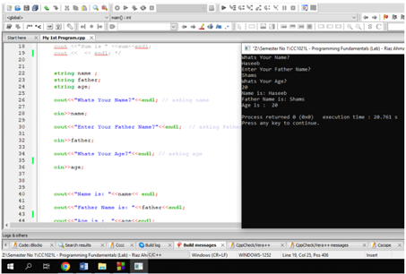

**My 1st  Project Source Code**

#include <iostream>

#include <cmath>

#define PI 3.14159

using namespace std;

int main()

{

double radius, volume;

cout << "Enter the radius: ";

cin >> radius;

volume = 4.0 / 3.0 * PI * pow(radius, 3);

cout << "The radius of the sphere is: " << radius << endl;

cout << "The volume of the sphere is: " << volume << endl;

return 0;

}

The End